Cite all sources using the CSE method (or ISO 690 Numerical in Word). The first example has been done for you. Highlight all objective 1 command terms in yellow and complete these before the next class. Highlight all objective 2 and 3 command terms in green – these will be part of the discussions in class.
Answer all objectives and complete the self-assessment rubric before submitting.

- Define the following:
Cell cycle | All stages in the life cycle of a cell. ⁽¹⁾
Interphase
Mitosis
Cytokinesis
Apoptosis
Necrosis
Diploid
Haploid

- Distinguish between cell division and mitosis.

- Other than maintaining optimum cell size, list four processes involving division by mitosis.

- Explain why eukaryotes need to use mitosis in cell division when prokaryotes do not.

- Identify the outcome of one division by mitosis.

- Draw and label a pie chart to show the relative amount of time spent in each phase of the cell cycle, including the stages of interphase and mitosis, as well as cytokinesis.

- Outline the stages of interphase.
Stage | Events

- List three metabolic reactions that occur during interphase.

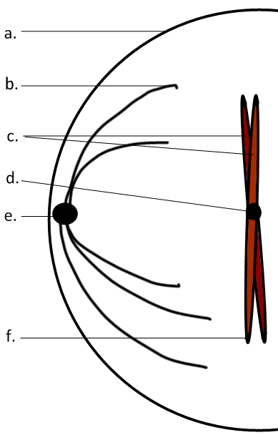
- Label the diagram.
a | Plasma membrane
b
c
d
e
f | telomeres

- Distinguish between chromosomes and chromatids.

- Outline the stages of mitosis of an animal cell with a chromosome number of four.

 | Diagram | Outline
Prophase | 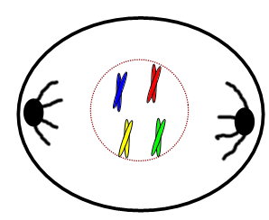
Metaphase
Anaphase
Telophase

- Using the table below, explain how mitosis leads to two genetically identical nuclei.

Chromosome number
S-phase
DNA Replication | Semi-conservative, complementary base-pairing results in fewer mistakes and copies of all genes in all new chromosomes.
Metaphase
Anaphase

- Distinguish between mitosis and cytokinesis.

- Cancer is an increasing global health concern, related to problems with cell division.
- Define tumour.

- State the locations or tissues where tumours:
- Can possibly occur.

- Are most likely to occur

- Outline the role of the P53 gene and how it can be affected by carcinogens.

Works Cited
1.

2.

Self Assessment:
 | Essential Biology |  |  | Assessment
Criterion | Complete (2) | Partially complete (1) |  | Self | Dr. B
Presentation &Organisation | NA | Complete and neat.  - All command terms highlighted  - Tables and diagrams well presented.  - Assignment is self-assessed
Academic Honesty | NA | At least two sources cited correctly using the CSE (ISO 690 numerical) method, with Works Cited section complete and correct.
Objective 1 understanding | All answers for the following command terms correct: | Most answers for the following command terms correct:
 | Define Draw Label List Measure State
Objective 2 understanding | All answers for the following command terms correct: |  | Most answers for the following command terms correct:
 | Annotate Apply Calculate Describe Distinguish Estimate Identify Outline
Objective3  understanding | All answers for the following command terms correct: |  | Most answers for the following command terms correct:
Analyse Comment Compare Construct Deduce Derive Design Determine Discuss
Evaluate Explain Predict Show Solve Sketch Suggest
Further Research | NA | Evidence is apparent of research and reading beyond the textbook and presentations to find correct answers to challenging questions. If any questions are unanswered, this criterion scores zero.
Timeliness | NA | Assignment is completed on the date it is due  - Full credit when on time  - No points awarded if one day late  - -1 point if two days late  - -2 if three days late, etc…
 | Total (max 10):

