Scientists use a device called a “calorimeter”, shown in Figure 1, to measure the amount of chemical potential energy in all sorts of materials.. To determine the chemical energy of a material, scientists first measure the mass of a sample of the material. They then place the sample in a sealed container called a “bomb”. They put the bomb in a well-insulated container filled with a known volume of water. An electrical spark from inside the bomb starts the sample burning. The water in the container absorbs the energy released by the burned sample. A thermometer measures the change in the temperature of the water. The potential energy of the original material is equal to the thermal energy transferred to the water.

Figure 1. Calorimeter “Bomb”

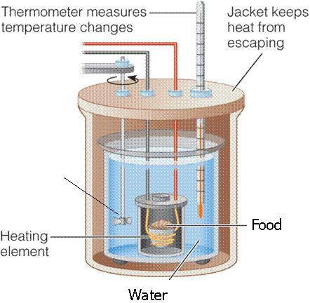

In this activity, you will use a simplified calorimeter device made out of a soda can to measure the amount of calories in a sample of food.

SAFETY MEASURES

- Wear safety goggles during this investigation
- Long hair must be tied back.
- If anything other than the food material begins to burn, notify your teacher immediately
- Be especially careful to keep clothing and sleeves away from the open flame.
- The can may become quite hot. Carefully follow all instructions written in the procedure and provided by your teacher.
- A note about food sensitivities: if you are allergic to any of the food items, please notify your teacher. Sensitive individuals should not participate in the burning of the material that may result in exposure.
- No eating or drinking in the lab.

Materials:

For each group:
Soda can (empty)
Glass Stirring rod
Ring stand and ring
Thermometer probe (lab-quest)
Mini adapter
Electronic balance
Cork
Metal paper clip
Graduated cylinder
Wood stick (for lighting your sample)

Procedure:

CLEAR SPACE OF ALL FLAMMABLES

- Using the graduated cylinder, obtain 50 mL of water and carefully pour it into the soda can.
- Determine the mass of the water and record your finding in the data table provided. (Hint: density of water is 1 g/mL)
- Hold the paper clip horizontally and bend the outer end upwards until it is at a 90 degree angle to the rest of the paper clip.
- Obtain foil-covered the cork.
- Insert the paper clip into the foil-covered cork.
- Insert the stirring rod through the soda can tab and position the can in the ring stand so that the stirring rod supports it (see Figure 2).

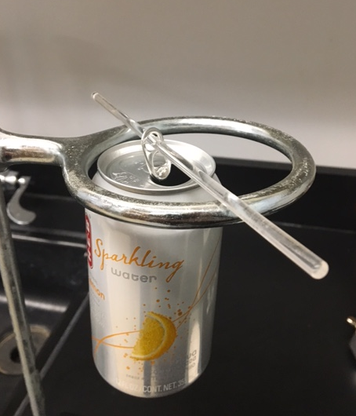
Figure 2.

- Adjust the ring stand so that the can is approximately 4 cm above the food sample (Figure 4).

- Suspend the thermometer inside the can and let the edge of the thermometer cover rest against the can (see figure 3).
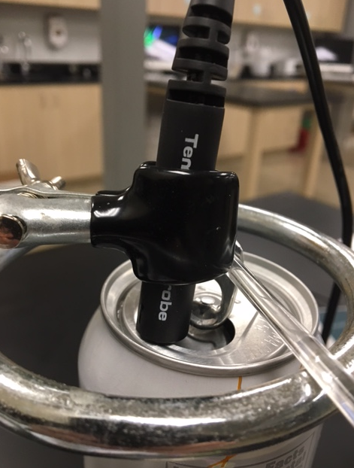
Figure 3.

- Attach the temperature probe to the lab-quest mini adapter and connect this to the desk top computer
- Open “logger pro” and take an initial temperature reading of the water.
- Measure the mass of your food material and record it in the data table.
- Now attach the food to the paper clip as shown in Figure 4.

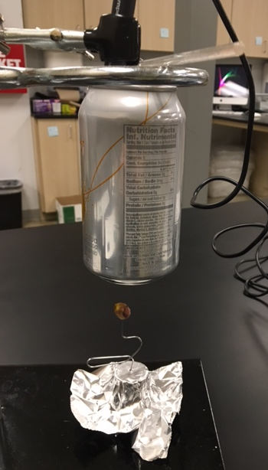
Figure 4

- Show your teacher your experimental set-up before igniting your food material.
- Once you have received approval for your experimental set up, initiate data collection in logger-pro and ignite your food material.
- Carefully, use a lit wooden stick to ignite your sample.
- Allow the lit sample to heat the water in the can. Black soot will accumulate on the underneath side of the can.
- Monitor the temperature increase with logger pro.
- Stop data collection after the sample burns out.
- Find the remaining mass of the burned sample.
- Repeat for additional food samples as time permits.

DATA COLLECTION TABLE

Measurement | Sample 1 | Sample 2 | Sample 3 | Sample 4 | Sample 5
Mass of water

Initial mass (food plus paper clip) g
Initial Water temperature (Celsius)
Final Water Temperature (Celsius)
Final mass (Food sample plus paper clip: g)
ΔT ( ºC)
Starting Mass of food
(less mass of paper clip: 1 g)
Final Mass of food
(less mass of paper clip: 1 g)

Δ mass (g)

Results:

 | Sample 1 | Sample 2 | Sample 3 | Sample 4 | Sample 5
Energy released (calories)
Calories to kilocalories (1 kcal = 1000cal)
Calories per mass (cal/g)

Note: Show all calculations on the sheet provided.

1. Calculate the energy (in calories) released by the burning food sample and absorbed by the water.

Q = m x Cp x ΔT

Q = heat absorbed by the water, m = mass of water in g, Cp = 1 cal/g ºC, ΔT = change in temperature

Q = ________________ calories

2. Record results in the table provided.
3. Determine the number of kilocalories (food calories) released by the burning food sample. (1 kilocalorie = 1000 calories)
4. Calculate the energy contained in the food in kilocalories / g
5. Using information on a nutrition label, calculate kcal/ g. (Divide calories per serving by the number of grams per serving).
6. Compare your experimentally determined energy content (in kilocalories/g) to the calculated value from the nutrition label. Calculate the percent error for your experiment.
7. How might you represent your data findings graphically?

Post lab Reflection:
Please type your answers to the following questions.

- Explain the sources of error in your experiment.
- Explain, in terms of energy transfer and transformation, what caused the temperature of the water to change.
- Was all of the energy contained in the burning food transferred to the water? If not, explain what happened to the energy that was not transferred to the water.
- How could you improve upon the design of this calorimeter so that it would work better?
- Draw a detailed labeled diagram of your improved calorimeter.
- Explain why this design is better than the one that you used.

- A curious student wanted to know if the calorimeter would work with different amounts of water. The table below shows the results from her burning food material of the same size and mass, but using varied amounts of water in the can. Explain from the table below whether the calorimeter measured the energy in the food material properly when used with each amount of water.

Experiment | Mass of water (g) | Δ T (ºC)
Sample 1 | 200 | 19
Sample 2 | 100 | 39
Sample 3 | 50 | 77

Calculations:

