Investigation of the factors Affecting Membrane Integrity
Subject: Beet Root

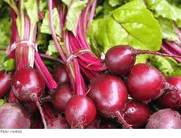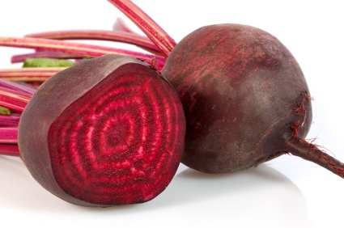
Beet Root is the taproot portion of the Beet Plant. The scientific name is Beta vulgaris and the plant has a rich history as a natural coloring agent as well as for medicinal purposes. The color comes from a pigment, betacyanin or betalain (Figure 2) stored inside the vacuole of the root cells. Betacyanin cannot pass through cell membranes but can pass through cellulose (ie, cell walls), if membranes are disrupted.)
Figure 2
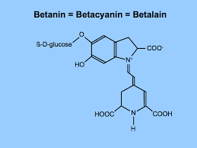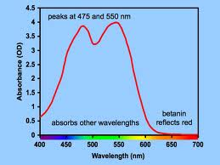

The ring structures cause the molecule to absorb light in the 475 nm wavelength range (the color you see is the color reflected).

Question: What function to betalains play in plants?

In beetroot, the pigment is sequestered inside the central vacuole which is separated by a membrane from the rest of the cell by the tonoplast.

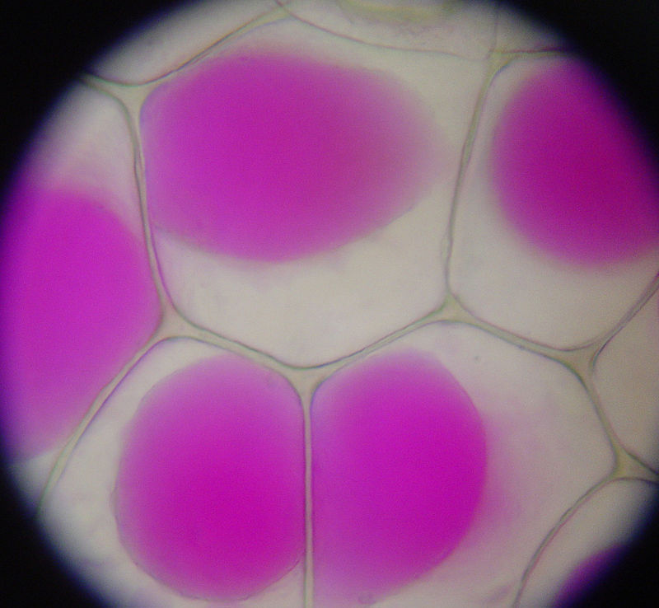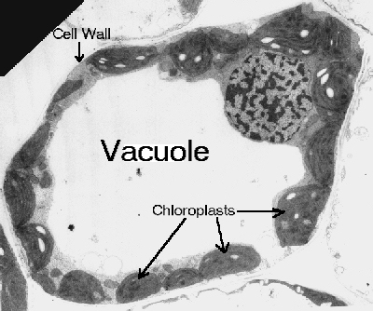
Tonoplast

Predict what will happen if the tonoplast and plasma membrane are disrupted.

For this experiment, the goal is to collect quantitative data, with replicates, to ensure statistical confidence. You will be provided with test tubes for the experiment (3 sets of 3) and a set of 6 spectrophotometer cuvettes (small test tubes). In addition to the spectrophotometer (which measures absorbance) and assorted measuring tools, you will have access to:

4 mm beet cores (X 3, soaked in distilled water overnight)
a digital thermometer
ice
a hot water bath (60ºC, crock pot)
acetic acid 5% (vinegar)
hydrogen peroxide (H₂0₂)
saturated salt solution (26% NaCl)
detergent (colorless)
distilled water
pH paper
ruler
scaplel
spectrophotometer (to measure absorbance/wavelength)
microscopes

To conduct this experiment, you must decide which treatment you will expose your beetroot cores to.

Each treatment will be conducted in replicate. Raw data must be documented in a table and converted into a visual form (graph) in your final report.

Health and Safety

Handle cutting tools with care.
Be mindful of hot water with the potential to burn.
Beetroot juice may stain skin and clothing but is non-hazardous. Wear a lab apron to protect clothing.

Procedure

For this procedure, you must carefully cut your beetroot cores in equal sizes. Multiple core segments may be placed in each treatment to increase confidence in the results.

You must decide on the amount of the beet root used in the experiments. You must also decide on the TIME of each treatment (but you must keep the time constant across all treatments that you are comparing).

You can compare several treatments or the same treatment under several conditions. Document these variables in a table.

Document your hypothesis:
PROCEDURE:
 | Variable measured | Method of measuring
Independent Variable
Dependent Variable
Controlled Variable

RESULTS:

 | Condition | Replicate 1 | Replicate 2 | Replicate 3
1

2

3

Question: Why do you include replicates in your procedure? What can you do with the replicated results to increase your confidence in your results?

Reflection Questions:

- Evaluate your method for this investigation. Think about which factors have been controlled to make it a fair test. Consider whether any factor other than temperature could be responsible for the color leaking from the beetroot cores. Do you think this experiment has given you valid results? Explain why or why not.
- What is the relationship between the amount of pigment released from the beetroot and the treatment you exposed the beetroot to?
- If you altered the pH of your solution, how can you determine whether the acidity altered the color of the pigment vs. released pigment from cells?
- Plan an investigation to determine why handling raw cabbage does not stain your fingers very much but handling pickled cabbage does.

Final report:

You will turn in a report that includes your hypothesis statement, a description of your method, raw data tables and at least one graphical representation of transformed data, along with answers to the questions contained in this report. Each person will turn in an individual report. Report is due one week from the date of the lab.

