Blog resource: <http://tinyurl.com/l363hk> Click4Biology: <http://tinyurl.com/35gzg34>

Highlight all objective 1 command terms in yellow and complete these **before class**. Highlight all objective 2 and 3 command terms in green – these will be part of the discussions in class. After class, *go back and review them*.

Complete the **self-assessment rubric** before turning in.

1. Define the following:

|  |  |
| --- | --- |
| Erythrocyte | *Red blood cell, transports oxygen.* (1 p. 49) |
| Leukocyte |  |
| --Lymphocyte |  |
| --Phagocyte |  |
| Platelets |  |
| Plasma |  |
| Myogenic |  |
| Artery |  |
| Vein |  |
| Capillary |  |
| Pulmonary |  |

1. The blood carries heat. List six further materials carried in the blood.

* Water,

1. a. State the name and function of the blood vessels labeled in this image:

Blood vessels:

Function:

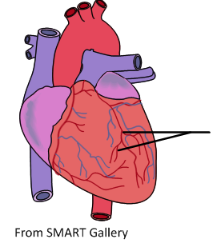

b. Further learning: outline the cause and effects of a *myocardial infarction*.

1. Label the vessels, chambers and valves in the heart:

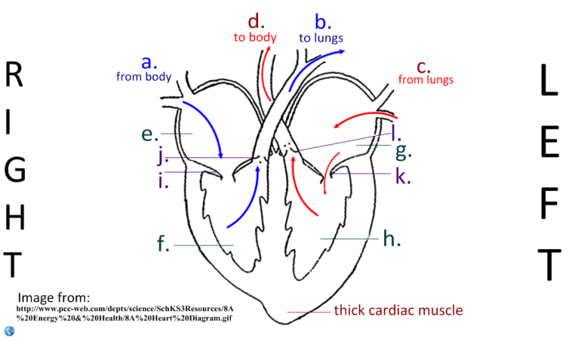

|  |  |  |  |  |  |
| --- | --- | --- | --- | --- | --- |
| **Blood vessels** | | **Chambers of the heart** | | **Valves** | |
| a. |  | e. |  | i. |  |
| b. |  | f. |  | j. |  |
| c. |  | g. |  | k. |  |
| d. |  | h. |  | l. |  |

1. Explain the action of the heart.
   * Blood flows in to the atria from veins.

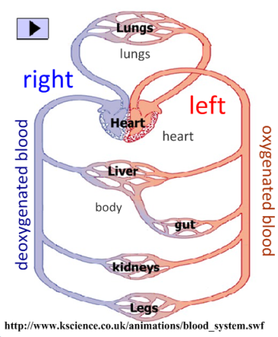

1. State the role of valves in the circulatory system.
2. Describe why the flow of blood is considered a *double circulation*.
3. 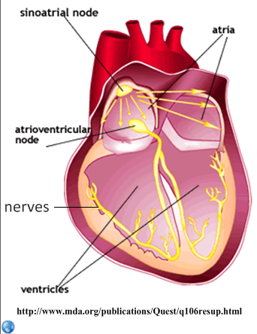Outline the control of the heartbeat.

|  |  |
| --- | --- |
| Myocytes |  |
| Myogenic |  |
| Sinoatrial node |  |
| Nerves |  |
| Ventricles |  |
| Medulla (brain) |  |
| Epinephrine |  |

1. Explain how exercise leads to an increase in heart rate.
2. 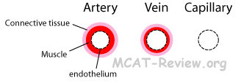Explain the relationship between the structure and function of these blood vessels.

|  |  |  |
| --- | --- | --- |
| **Artery** | **Vein** | **Capillary** |
|  |  |  |

1. Marine mammals have a series of physiological responses to diving. This enables them to stay submerged for long periods in water colder than their body temperature. Collectively these responses are termed the diving reflex.

To investigate the diving reflex in humans, heart rate changes in ten healthy subjects were monitored during facial immersions in water ranging from 3 °C to 37 °C. The data for this experiment is shown below.



[Source: N R York, *Effect of Water Temperature on Diving Reflex Induced Bradycardia in Humans,*http://kesler.biology.rhodes.edu/sciJ/York.html]

(a) (i) State the effect of facial immersion on heart rate over the range of temperatures shown on the graph.

(1)

(ii) Suggest **one** reason for the relationship between facial immersion and heart rate.

(1)

(b) Outline the effect of the water temperature on heart rate.

(1)

(c) Calculate the heart rate of a person immersed in water at a temperature of 15°, if their heart rate before immersion was 70 beats per minute.

(2)

(Total 5 marks)

*Question from QuestionBank CDROm*

# Works Cited

1. **Allott, Andrew.** *IB Study Guide: Biology for the IB Diploma.* s.l. : Oxford University Press, 2007. 978-0-19-915143-1.

2. **Mindorff, D and Allott, A.** *Biology Course Companion.* Oxford : Oxford University Press, 2007. 978-099151240.

3. **Clegg, CJ.** *Biology for the IB Diploma.* London : Hodder Murray, 2007. 978-0340926529.

4. **Campbell N., Reece J., Taylor M., Simon. E.** *Biology Concepts and Connections.* San Fransisco : Pearson Benjamin Cummings, 2006. 0-8053-7160-5.

5. **Taylor, Stephen.** *Science Video Resources.* [Online] Wordpress, 2010. http://sciencevideos.wordpress.com.

6. **Burrell, John.** *Click4Biology.* [Online] 2010. http://click4biology.info/.

7. **IBO.** *Biology Subject Guide.* [Online] 2007. http://xmltwo.ibo.org/publications/migrated/production-app2.ibo.org/publication/7/part/2/chapter/1.html.

**Self Assessment:**

|  |  |  |  |  |  |
| --- | --- | --- | --- | --- | --- |
|  | **Essential Biology** | | | **Assessment** | |
| **Criterion** | **Complete (2)** | **Partially complete (1)** | | **Self** | **Dr.B** |
| Presentation & Organisation | NA | Complete and neat. All command terms highlighted, tables and diagrams well presented. | |  |  |
| Academic Honesty | NA | Sources cited using the CSE (ISO 690 numerical) method, with Works Cited section complete and correct. | |  |  |
| **Objective 1** understanding | **All** answers for the following command terms correct: | Most answers for the following command terms correct: | |  |  |
| **Define Draw Label List Measure State** | | |
| **Objective 2** understanding | **All** answers for the following command terms correct: | | Most answers for the following command terms correct: |  |  |
| **Annotate Apply Calculate Describe Distinguish Estimate Identify Outline** | | |
| **Objective3**  understanding | **All** answers for the following command terms correct: | | Most answers for the following command terms correct: |  |  |
| **Analyse Comment Compare Construct Deduce Derive Design Determine Discuss**  **Evaluate Explain Predict Show Solve Sketch Suggest** | | |
| Logic, notation, mathematical working | NA | Answers are presented in a logical and concise manner. SI units used most times, with correct unit symbols and definitions of terms. All mathematical working shown. | |  |  |
| Further research | NA | *Evidence* is apparent of research and reading beyond the textbook and presentations to find correct answers to challenging questions. **If any questions are unanswered, this criterion scores zero.** | |  |  |
|  | **Total (max 10):** | | |  |  |